
Sreenidhi Institute of Science and Technology
H.T No
Regulations:
A20
(An Autonomous Institution)
Code No: 8A282 Date: 22-Feb-2025 (FN)

B.Tech I-Year II- Semester External Examination, February - 2025 (Supplementary) COMPREHENSIVE VIVA TEST - II (EEE)

Time: 3:00 Hours Max.Marks:70
Note: Answer Any 70 Questions.
Student can solve more than 70 questions, but maximum 70 marks will be awarded.
Calculator's are not allowed.

S.No | Question
1. | The valve of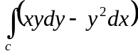, where c is the square cut from the first quadrant by the lines x=1 and y=1  a) 1 b) 1/2 c)3/2 d)5/2
2. | If 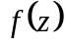 is analytic function in the entire z-plane and bounded everywhere, than  a) 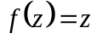 b)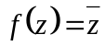 c) 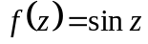 d) 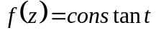
3. | If is analytic in domain D, then is  a) Continuous in D b) Continuous but not necessary differentiable in D  c) Neither Continuous nor differentiable in D d) differentiable in D
4. | If =log z, then  a) Satisfies Cauchy Riemann Equation b) is analytic  c) is not analytic d) none of the above
5. | The value of integral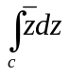,where C is the shortest path joining A(0,0) to B(1,1) is  a) 1 b)2 c)I d)0
6. | The value of the integral 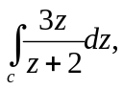where 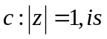  a)1 b)2 c)3 d)0
7. | Ideal voltage source has _______  a) Zero internal resistance b) infinite resistance  c) low value of current d) large value of emf
8. | Nodal analysis is based on _________  a) KCL b) KVL c) Both d) law of conservation of energy
9. | The graph of a network has 8 nodes and 5 independent loops. The number of branches of graph is _  a) 11 b) 12 c) 13 d) 14
10. | The no ‘of independent loops for a network with ‘n’ nodes & ‘b’ branches is  a) n-1 b) b-n c) b-n+1 d) b+n-1
11. | A 2cm long coil has 10turns and carries a current of 750mA. The magnetising force of the coil is _  a) 225AT/m b) 675AT/m c) 470AT/m d) 375AT/m
12. | The reciprocal of reluctance is _________  a) susceptibility b) permeability c) permeance d) Reluctivity
13. | The ratio of maximum value to R.M.S value is known as  a) Form factor b) Peak factor c) Zero factor d) UPF
14. | The ratio of R.M.S value to Average value is known as  a) Form factor b) Peak factor c) Zero factor d) UPF
15. | In steady state conditions inductor acts as  a) UPF b) LPF c) Short circuit d) Open circuit
16. | In steady state conditions Capacitor acts as  a) LPF b) Short circuit c) UPF d) Open circuit
17. | Superposition theorem is not applicable to  a) Nonlinear elements b) transformers c) port networks d) Dependent sources
18. | Reciprocity theorem is valid to  a) Linear elements b) Single source circuits c) Diodes d) Transformers
19. | Thevenin’s resistance is obtained by  a) SC current source b) OC current source c) SC voltage source d) both B & C
20. | Norton’s resistance is obtained by  a) SC current source b) OC current source c) OC voltage source d) both B & C
21. | Following tools are used in bench and fitting shop  a) Marking tools b) Divider c) Scriber d) The entire above
22. | Following is used as marking tool  a)prick punch b )hack saw c) mallet (d) All of the above
23. | Following is used as measuring tool  a) File b) Steel rule c) Hammer d) all of the above
24. | Domestic electrical wiring is basically a  a)Series connection b)Parallel connection  c)Combination of series and parallel connections  d)Series connection within each room and parallel connection elsewhere
25. | In electrical wiring the fuse should be placed  a) In earth wire b) Live or phase wire c) Neutral wire d) In lamp directly.
26. | The type of wiring that is highly suitable for a temporary shed is  a)Cleat wiring b)Wooden capping and casing wiring  c)Lead sheathed wiring d)Conduit wiring
27. | Rip saw is generally used to ________.  a) Cut wood b) cut metal c) Ceramic d) none of these
28. | - Which of the following tool is used to make the surface plain?  a) Metal jack plane b) Mallet c) Try square d) None of these
29. | carpentry vice is a  a) Holding vice for metals b) Holding vice for woods c) Cutting device d) Measuring device
30. | Which of the following materials is not made by injection molding?  a) Nuts b) tubes c) car handles d)Electrical fittings
31. | Which of the following plastics is not used in blow molding  a) terephthalate b)polypropylene c)polyethylene d)pvc
32. | The temperature range for the soldering process is.....  a) 40ºC to 100ºC b).180ºC to 250ºC c)600ºC to 900ºC d)1000ºC to 2000ºC
33. | Arc-welding uses the following electric supply .........  a).A.C. b)D.C. c) Both AC and DC d)Spiral waveform
34. | Lathe bed is made of ________  a) carbon steel b) stainless steel c) cast iron d) wrought iron
35. | Which of the following is typically the most expensive type of 3D printer?  a)SLA b)SLM c)FDM d)none of the above
36. | Process of inserting an element in stack is called ____________  a) Create b) Push c) Evaluation d) Pop
37. | In a stack, if a user tries to remove an element from an empty stack it is called _________  a) Underflow b) Empty collection c) Overflow d) Garbage Collection
38. | What is the value of the postfix expression 6 3 2 4 + – *?  a) 1 b) 40 c) 74 d) -18
39. | Which of the following statement about binary tree is CORRECT?  a) Every binary tree is either complete or full b) Every complete binary tree is also a full binary tree  c) Every full binary tree is also a complete binary tree d) A binary tree cannot be both complete and full
40. | Which type of traversal of binary search tree outputs the value in sorted order?  a) Pre-order b) In-order c) Post-order d) None
41. | A Binary Tree can have  a) Can have 2 children b) Can have 1 children c) Can have 0 children d) All
42. | struct node  {  int data;  struct node * next;  }  typedef struct node NODE;  NODE *ptr;  Which of the following c code is used to create new node?  a) ptr=(NODE*)malloc(sizeof(NODE)); b) ptr=(NODE*)malloc(NODE);  c) ptr=(NODE*)malloc(sizeof(NODE*)); d) ptr=(NODE)malloc(sizeof(NODE));
43. | In linked list each node contain minimum of two fields. One field is data field to store the data second field is?  a) Pointer to character b) Pointer to integer c) Pointer to node d) Node
44. | Minimum number of fields in each node of a doubly linked list is ____  a) 2 b) 3 c) 4 d) None of the above
45. | What is the best case and worst case complexity of ordered linear search?  a) O(nlogn), O(logn) b) O(logn), O(nlogn) c) O(n), O(1) d) O(1), O(n)
46. | Binary Search can be categorized into which of the following?  a) Brute Force technique b) Divide and conquer  c) Greedy algorithm d) Dynamic programming
47. | Which of the following term is used for a function defined inside a class?  a) Member Variable b) Member function c) Class function d) Classic function
48. | Cout is a __________  a)operator b) function c) object d) macro
49. | Which keyword should be used to declare static variables?  a) static b) stat c) common d) const
50. | Which is the correct syntax for declaring static data member?  a) static memberName dataType b) dataType static memberName  c) memberName static dataType d) static dataType memberName
51. | Communication is the transfer of ________ from one person to another person.  a) Information b) Understanding c) opinions d) both a and b
52. | Which one of the following is not a part of the stages of communication?  a) Ideation ssb) Translation c) Transmission d) Response
53. | Which one of the following is not a channel of communication?  a) Zigzag b) Diagonal c) Horizontal b) Downward
54. | Many of the students complained that the test was difficult,-------- they could score full marks.  a) yet b) so c) because
55. | .-------- our constant disagreements, we remained fast friends.  a) Although b) Unless c) Despite
56. | ---------- the bad weather we went sailing.  a) However b) In spite of c) Because
57. | _____________ are personality traits and behaviours.  a)Soft skills b) Hard skills c)Technical skills d) Listening Skills
58. | You can help train yourself to think in __________ by first translating the thoughts in your head.  a)English b) Telugu c) Hindi d) Any other language
59. | Challenge yourself to _______ a story that someone else shares in English to check your comprehension and understanding.  a) tell b)retell c) recite d) read
60. | Identify the written presentation from the given options.  a) Memos b) Seminar c) Press conference d) Symposia
61. | Which among the following is not the nature of oral presentation?  a)Purposeful b) Interactive c) Formal d) Speaker-oriented
62. | Find out the 4Ps of an effective presentation.  a) Plain, prepare, practice, perform b) Please, prepare, preach, perform  c) Plain, propagate, practice, perform d) Plain, prepare, practice, praise
63. | What is the important factor for note-taking?  a) Note taking medium b) Instrument for note taking c) Your note taking speed d) All of the above
64. | Intensive reading refers to  a) Reading a text for detailed information b) Reading a text for pleasure  c) Reading a text for editing d) Reading a text for someone else
65. | Which of the following options represents the correct bond order :  a). O₂⁺ > O₂ > O₂⁻ > O₂²⁻ b). O₂ > O₂⁺ > O₂⁻ > O₂²⁻ c). O₂²⁻ > O₂ > O₂⁺ > O₂⁻ d). O₂⁻ > O₂²⁻ > O₂⁺ > O₂
66. | Antibonding molecular orbitals are produced by  a). constructive interaction of atomic orbitals. b). destructive interaction of atomic orbitals.  c). the overlap of the atomic orbitals of two negative ions d). all of these e). none of these
67. | An increase in the conductivity equivalent of a solid electrolyte with dilution is primarily due to  a) increased ionic mobility of ions b) 100 percent electrolyte ionisation with natural dilution  c) increase in both ion numbers and ionic mobility d) A rise in ion counts
68. | A device that converts the energy of combustion of fields like hydrogen and methane directly into electrical energy is known as  a) Electrolytic cell b) Dynamo c) Ni-Cd cell d) Fuel cell
69. | An electrolytic cell uses electrical energy to drive  a) chemical reaction b) physical reaction c) no reaction d) biochemical reaction
70. | The emf of the dry cell is about  a) 0 V b) 0.5 V c) 1 V d) 1.5 V
71. | The calomel electrodes are classified based on which of the following?  a) Materials used in the electrode b) Amount of mercury present  c) Concentration of KCl d) Purity of mercury
72. | Carbonyl compounds especially ketones undergo reduction to form  a) Primary alcohols b) Secondary alcohols c)Alkanes d) Alkenes
73. | Acetaminophenol is  a) Aspirin b) Paracetamol c) Benadryl d) Nimsulide
74. | In SN1 reaction, the rate of reaction is proportional to the  a) Concentration of substrate b) concentration of nucleophile  c) both a & b d) none of the above
75. | The ease of dehydrohalogenation of alkyl halide with alcoholic KOH  a) tertiary alkylhalide b)secondary alkylhalide c)primary alkylhalide d)none of the above
76. | Alcohol that does not undergo oxidation is  a) Methyl alcohol b) primary alcohol c) secondary alcohol d) tertiary alcohol
77. | For the corrosion of iron one of the following factor is essential  a) Presence of moisture b) presence of moisture & oxygen c) Presence of H d) presence of acid
78. | The buried pipe line is protected from corrosion by connecting to Mg block.  a) Impressed voltage protection b) sacriﬁcial cathodic protection  c) Sacriﬁcial anodic protection d) none of these.
79. | A man plants 15376 apple trees in his garden and arranges them so that there are as many rows as there are apple trees in each row. The number of rows is: (a)124 (b)126 (c)134 (d)144 (e)Data inadequate
80. | The average of six numbers is x and the average of three of these is y. If the average of the remaining three is z, then  a.) None of these b) x = y + z c) 2x = y + z d) x = 2y + 2z
81. | Suresh drives his car to a place 150 km away at an average speed of 50 km/hr and returns at 30 km/hr. What is his average speed for the whole journey ?
  a.32.5km/hr b) 35 km/hr. c) 37.5 km/hr d) 40 km/hr
82. | The average age of a husband and his wife was 23 years at the time of their marriage. After five years they have a one year old child. What is the average age of the family ?  a) 21years b) 20 years c) 18years d)19 years
83. | In an examination, a student's average marks were 63. If he had obtained 20 more marks for his Geography and 2 more marks for his history, his average would have been 65. How many subjects were there in the examination?  a) 10 b) 11 c) 13 d) 14
84. | The average salary of all the workers in a workshop is Rs.8000. The average salary of 7 technicians is Rs.12000 and the average salary of the rest is Rs.6000. How many workers are there in the workshop?  a) 21 b) 22 c) 23 d) 24
85. | Two numbers are in the ratio 2 : 3. If their L.C.M. is 48. what is sum of the numbers?  a) 28 b) 40 c) 64 d) 42
86. | Three numbers are in the ratio of 2 : 3 : 4 and their L.C.M. is 240. Their H.C.F. is:  a) 40 b) 30 c) 20 d) 10
87. | 9.The product of two numbers is 2028, their HCF is 13. What are the number of such pairs?  a) 4 b) 3 c) 2 d) 1
88. | .A, B and C start at the same time in the same direction to run around a circular stadium. A completes a round in 252 seconds, B in 308 seconds and C in 198 seconds, all starting at the same point. After what time will they again at the starting point ?  a) 36 m 22 sec b) 46 m 22 sec c) 36 m 12 sec d) 46 m 12sec
89. | Six bells start ringing together and ring at intervals of 4, 8, 10, 12, 15 and 20 seconds respectively. How many times will they ring together in 60 minutes ?  a)15 b) 31 c) 41 d)17
90. | Two students appeared at an examination. One of them secured 9 marks more than the other and his marks was 56% of the sum of their marks. What are the marks obtained by them?  a) 42, 33 b) 42, 36 c) 44, 33 d) 44, 36
91. | If 20% of a = b, then b% of 20 is the same as:  a) 10% of a b) 14% of a c) 4% of a d) none
92. | 14. Two numbers A and B are such that the sum of 5% of A and 4% of B is two-third of the sum of 6% of A and 8% of B. Find the ratio of A : B.  a) 2 : 1 b) 1:2 c) 1:1 d) 4:3  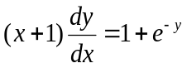
93. | The solution of is  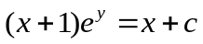a) b)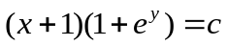  c)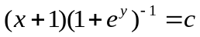 d)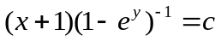
94. | The differential equation 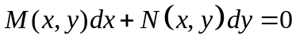is an exact equation if  a)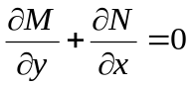 b)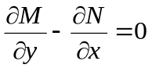  c)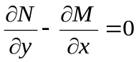 d)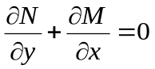
95. | The particular integral of 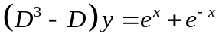, is  a)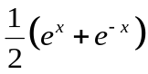 b)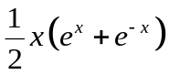  c)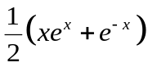 d)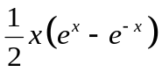
96. | 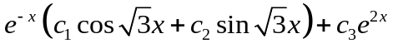, is the general solution of  a)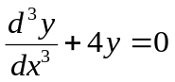 b)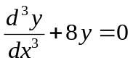  c)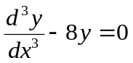 d)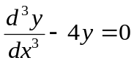
97. | a) 2 b) 1 c) -1 d) -2
98. | 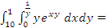  a) 9(1-e) b) 8(1-e) c) 9(e-1) d) 8(e-1)
99. | a) b) c) d)
100. | The valve of 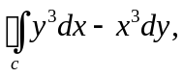where c is a circle of radius 2 centered in the origin  a) 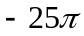 b) 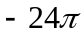 c) 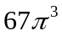 d) 87

-- 00 -- 00 –

